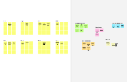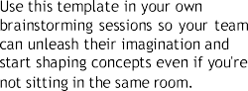

[**Open example**](https://app.mural.co/template/e5a93b7b-49f2-48c9-afd7-a635d860eba6/93f1b98d-b2d2-4695-8e85-7e9c0d2fd9b9)

See a finished version

[**Share template feedback**](https://muralco.typeform.com/to/CiqaHVat?typeform-source=app.mural.co)

**Brainstorm**



[**Share template feedback**](https://muralco.typeform.com/to/CiqaHVat?typeform-source=app.mural.co)

**Strengths, weaknesses, opportunities & threats**

Identify strengths, weaknesses, opportunities, and threats (SWOT) to develop a plan.

[**Open the template**](https://app.mural.co/template/6a062671-89ee-4b76-9409-2603d8b098be/ca270343-1d54-4952-9d8c-fbc303ffd0f2)

[**Open the template**](https://app.mural.co/template/e95f612a-f72a-4772-bc48-545aaa04e0c9/984865a6-0a96-4472-a48d-47639307b3ca)

**Customer experience journey map**

Understand customer needs, motivations, and obstacles for an experience.

[**Open the template**](https://app.mural.co/template/b7114010-3a67-4d63-a51d-6f2cedc9633f/c1b465ab-57af-4624-8faf-ebb312edc0eb)

**Strategy blueprint**

Define the components of a new idea or

**B Export the mural**

Export a copy of the mural as a PNG or PDF to attach to emails, include in slides, or save in your drive.

**Share the mural**

**Share a view link** to the mural with stakeholders to keep them in the loop about the outcomes of the session.

You can export the mural as an image or pdf to share with members of your company who might find it helpful.

Template

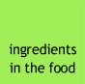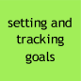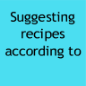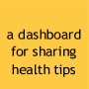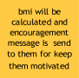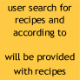

notifying harmful

about the health condition of the

user the diet plan

**HARI**

**MUKILAN**

There will be

their report they

User uploads

**POZHIL**

**DEEPAK**

If possible, be visual.

Go for volume.

Listen to others.

Defer judgment.

Encourage wild ideas.

To run an smooth and productive session

Due to the ignorance of healthy food habits, obesity rates are increasing at an alarming speed, and this is reflective of the risks to people’s health. People need to control their daily calorie intake by eating healthier foods, which is the most basic method to avoid obesity. However, although food packaging comes with

people to refer to App-based nutrient dashboard systems which can analyze real-time images of a meal and analyze it for nutritional content which can be very handy and improves the dietary habits, and therefore, helps in maintaining a healthy

lifestyle.

**Define your problem statement**

Due to unhealthy food habits obesity rates are increasing rapidly. Although food packaging comes with the nutritional content it is not sufficient. So we are going to build a web app.

**C Learn how to use the facilitation tools**

Use the Facilitation Superpowers to run a happy and productive session.

[**Open article**](https://support.mural.co/en/articles/2113740-facilitation-superpowers)

Think about the problem you'll be focusing on solving in the brainstorming session.

**A Team gathering**

Define who should participate in the session and send an invite. Share relevant information or pre-work ahead.

session. Here’s what you need to do to get going.

Monitor users progress

Then tracking

condition

notifying quotes

suggest

Apply the change in their dashboard

give feedback about the calories

image

classify the nutritional content present in the image

user is required to give their medical conditions to prepare diet for

them

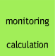

Calorie

and BMI

Get input from user

Take turns sharing your ideas while clustering similar or related notes as you go. than six sticky notes, try and see if you and break it up into smaller sub-groups.

Monitoring the health condition

monitoring

Classify nutritional content present in the food

Notifying harmful ingredients in the food

Sharing health tips

Tracking

of food

Recipes diet

Nutrition Assistant

Name of the food

Profile

necessary

report

user's

weight

Setting their goal

Personal details

Username and password

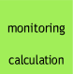

Regardless of their importance, which tasks are more

If each of these tasks could get done without any

which would have the most positive impact?

Calorie

and BMI

**Prioritize**

Your team should all be on the same page about what's important moving

which are feasible.

Classify nutritional content present in the

food

Setting their goal

name of the

report

Personal

details

Recepies diet

Monitoring the health condition

user's

weight

monitoring